CIRCLE GEOMETRY

Extended investigation Part 2: In-class validation
Solutions and marking key

Question 1 (a)

Angle in a Semicircle: An angle in a semicircle is a right angle.
Marking key/mathematical behaviours | Marks
- Correct description | 1

Question 1 (b)

Central Angle Theorem: The size of the angle at the centre subtended by an arc of the circle is twice the size of the angle at the circumference subtended by the same arc.
Marking key/mathematical behaviours | Marks
- Correct description | 1

Question 1 (c)

Angle in the Alternate Segment Theorem: An angle between a chord and a tangent is equal to any angle in the alternate segment.
Marking key/mathematical behaviours | Marks
- Correct description | 1

Question 1 (d)

Length of Tangents Theorem: Tangents drawn to a circle from an external point are equal in length.
Marking key/mathematical behaviours | Marks
- Correct description | 1

Question 1 (e)

Intersecting Chords Theorem: When two chords of a circle intersect, the product of the lengths of the intervals on one chord equals the product of the lengths of the intervals on the other chord.
Marking key/mathematical behaviours | Marks
- Correct description | 1

Question 1 (f)

Angles at the circumference of a circle subtended by the same arc are equal.
Marking key/mathematical behaviours | Marks
- Correct description | 1

Question 2

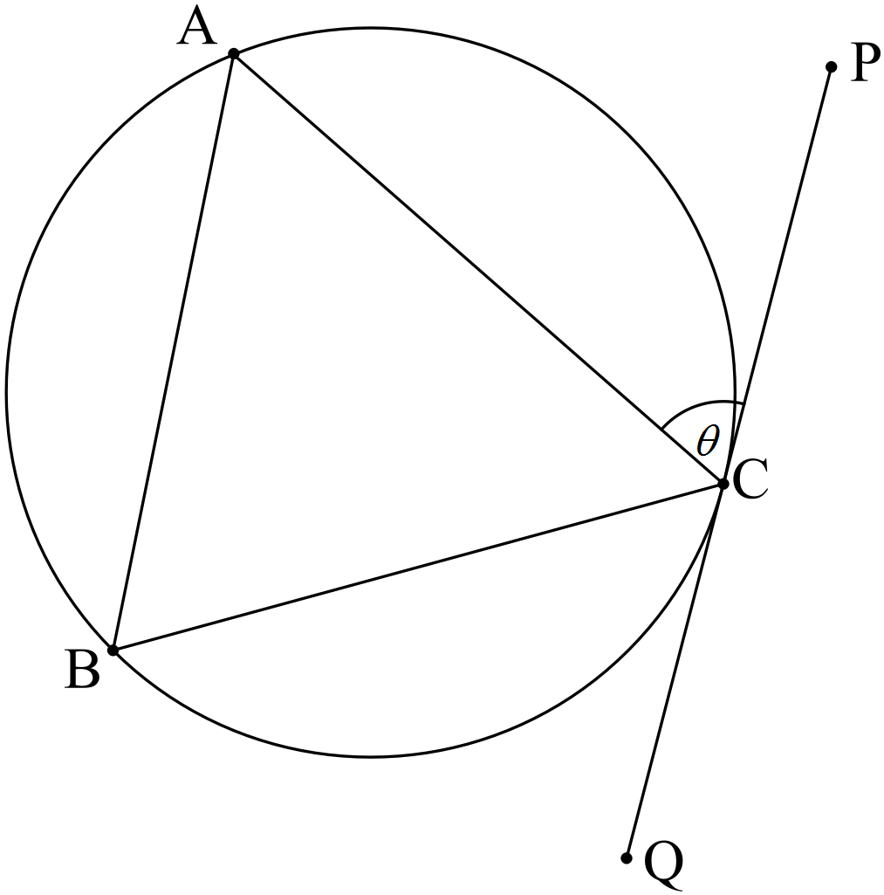

Given: PQ is tangential to the circle at C, CA = CB, .
To Prove: PQ is parallel to AB.
Proof:

Marking key/mathematical behaviours | Marks
- Establishes is isosceles  - Uses property of isosceles triangle to establish congruent angles  - Applies angle in alternate segment theorem  - Concludes alternate angles are congruent  - Concludes PQ is parallel to AB | 1  1  1  1  1

Question 3

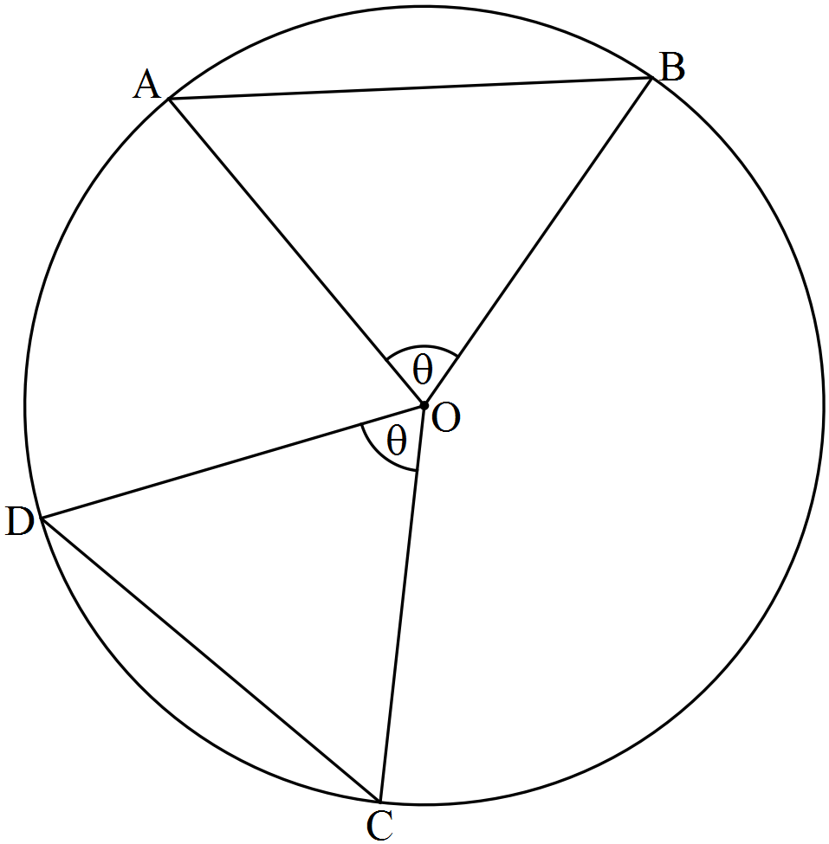

Given: Circle centre O with chords AB and CD, .
To Prove: Chords AB and CD are equal in length.
Proof:

Marking key/mathematical behaviours | Marks
- Establishes two pair of sides are congruent  - Gives reason, radii  - Establishes  - Gives reason  - Concludes chords equal in length | 1  1  1  1  1

Question 4

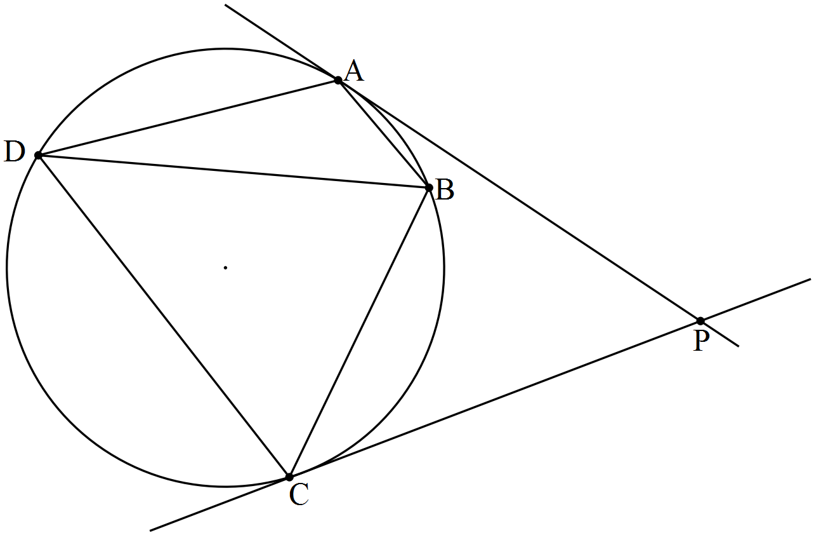
Given: A, B, C and D are four points on a circle such that ABC form a minor arc of the circle. The tangents at A and C meet at P.
To Prove:
Extension to
the diagram: Draw chord BD
Proof:

Marking key/mathematical behaviours | Marks
- Draws chord BD  - Applies angle in alternate segment theorem to  - Applies angle in alternate segment theorem to  - Establishes | 1  1  1  1

Question 5

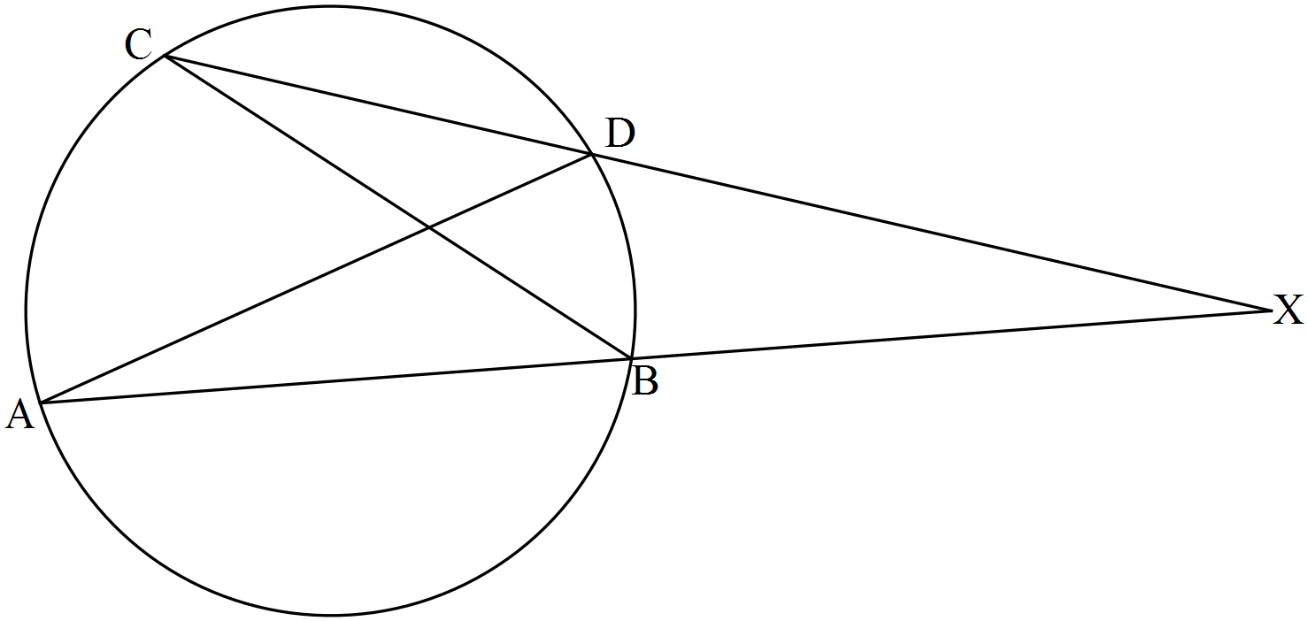

Given: Circle centre O with chords AB and CD intersecting externally at X.
To Prove: XA.XB = XC.XD
Extension to
the diagram: Draw chords AD and BC
Proof:

Marking key/mathematical behaviours | Marks
- Draws chords AD and BC  - Establishes  - Establishes  - States reason for similar triangles  - Equates ratios of corresponding sides  - Establishes product | 1  1  1  1  1  1

Question 6

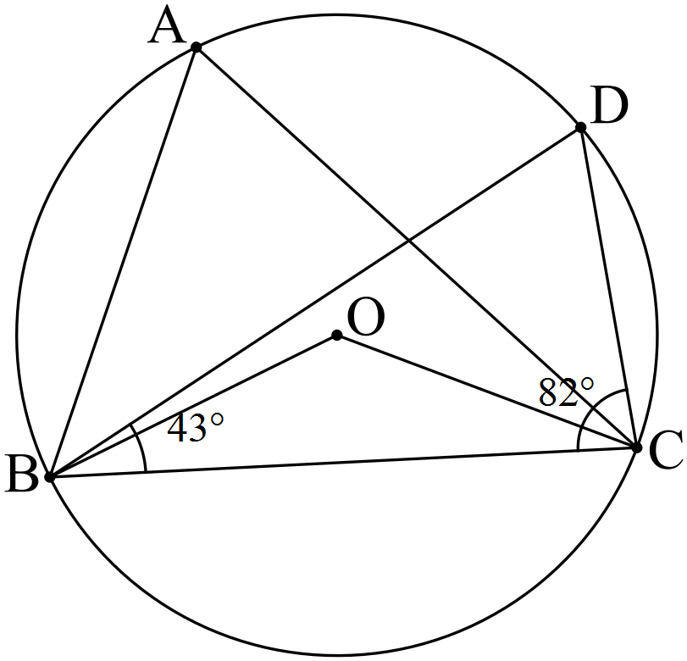
Marking key/mathematical behaviours | Marks
- Establishes size of  - Applies central angle theorem to determine size of  - Establishes is isosceles  - Establishes size of  - Establishes size of | 1  1  1  1  1

Question 7

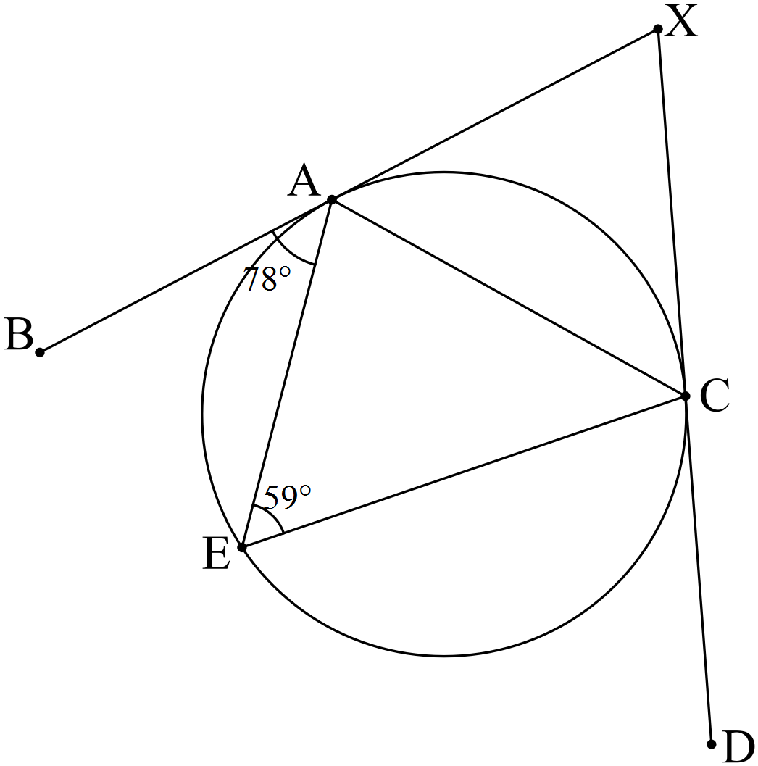

Marking key/mathematical behaviours | Marks
- Applies angle in alternate segment theorem to establish size  - Applies angle in alternate segment theorem to establish size  - Applies length of tangents theorem to establish  - Concludes  - Determines size of  - Uses straight angle to determine size of | 1  1  1  1  1  1

